Stepwise MLR Diagnostics – All Vars Model

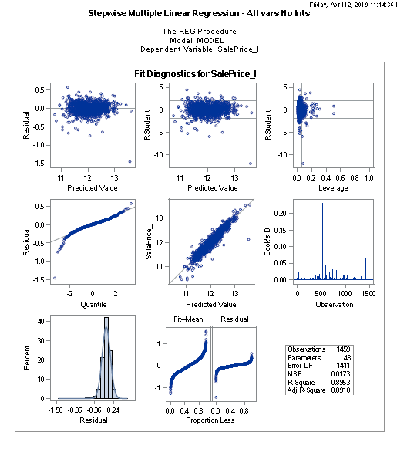

Stepwise MLR Diagnostics

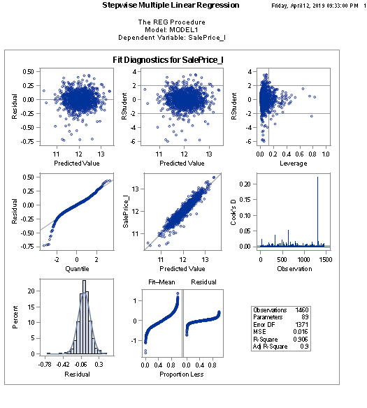

Forward MLR Diagnostics

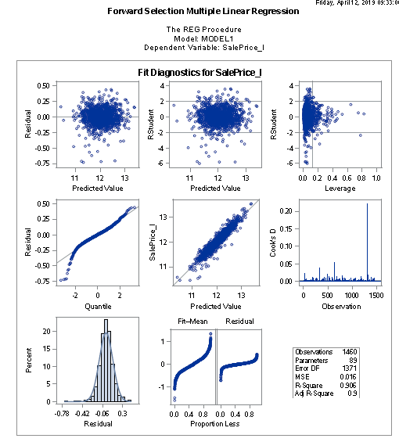

Backward MLR Diagnostics

